**ASSIGNMENT NO.5**

**Name – Indranil Bain**

**Enrollment NO. – 2020CSB039**

**Branch – Computer Science and Technology**

**Group - GX**

**Subject – DBMS Laboratory**

**Q1)**

**<A. Creation of tables:>**

**Customer Table**

create table Customer(

-> cust_id int primary key check(cust_id between 100 and 10000),

-> cust_name varchar(20),

-> annual_revenue int,

-> cust_type varchar(20) check(cust_type in ('MANUFACTURER','WHOLESALER','RETAILER')));

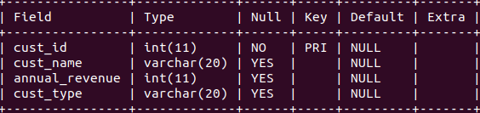

**After insertion of values:-**

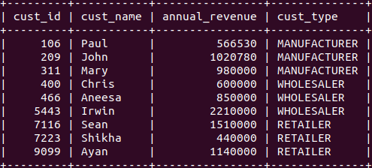

**Truck Table**

create table Truck(

-> truck_no int primary key,

-> driver_name varchar(20));

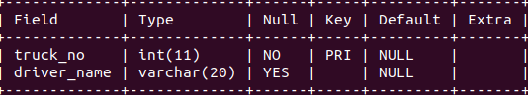

**After insertion of values:-**

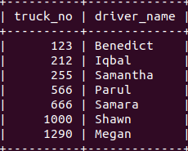

**City Table**

create table City(

-> city_name varchar(20) primary key,

-> population int);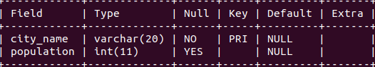

**After insertion of values:-**

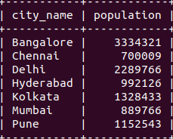

**Shipment Table**

create table Shipment

-> shipment_no int,

-> cust_id int references Customer(cust_id) on delete cascade,

-> truck_no int references Truck(truck_no) on delete set NULL,

-> destination varchar(20) references City(city_name),

-> weight int check(weight<1000),

-> ship_date date,

-> primary key(shipment_no,cust_id));

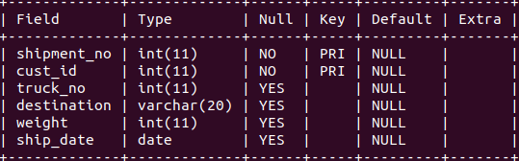

**After insertion of values:-**

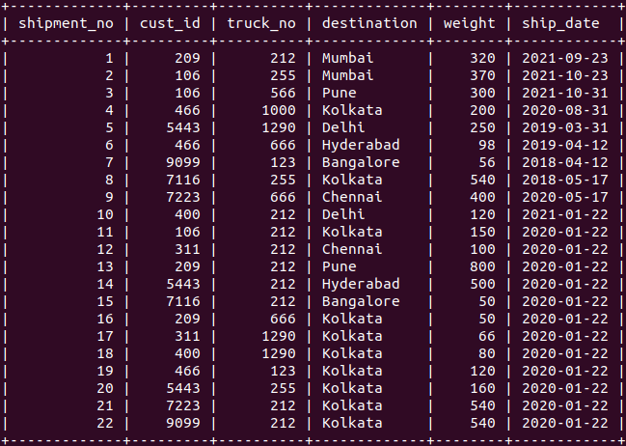

**<B. Queries >**

**a) Give names of customers who have sent packages (shipments) to Kolkata, Chennai and Mumbai.**

SELECT cust_name from customer NATURAL JOIN shipment WHERE shipment.destination='Kolkata' OR shipment.destination='Chennai' OR shipment.destination='Mumbai'

**b) List the names of the driver who have delivered shipments weighing over 200 pounds.**

select distinct(driver_name) from Truck,Shipment where Truck.truck_no= Shipment.truck_no and weight>200;

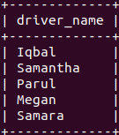

**c) Retrieve the maximum and minimum weights of the shipments. Rename the output as Max_Weight and Min_Weight respectively.**

select max(weight) as 'Max_Weight', min(weight) as 'Min_Weight' from Shipment;

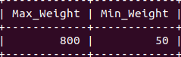

**d) For each customer, what is the average weight of the package sent by the customer?**

select distinct(cust_name),avg(weight) from Shipment,Customer where Shipment.cust_id=Customer.cust_id group by cust_name;

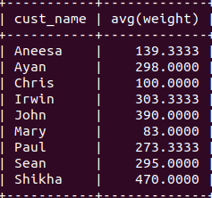

**e) List the names and populations of cities that have received shipments weighing over 100 pounds.**

select distinct(city_name),population from Shipment,City where destination=city_name and weight>100;

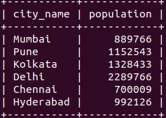

**f) List cities that have received shipments from every customer.**

select destination from Shipment group by destination having count(distinct cust_id)=(select count(cust_id) from Customer);

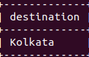

**g) For each city, what is the maximum weight of a package sent to that city?**

select city_name,max(weight) from Shipment,City where Shipment.destination=City.city_name group by city_name;

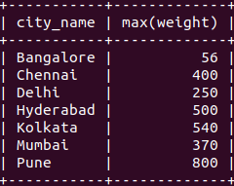

**h) List the name and annual revenue of customers whose shipments have been delivered**

**by truck driver ‘IQBAL’.**

select cust_name,annual_revenue from Customer,Shipment,Truck where Customer.cust_id=Shipment.cust_id and Truck.truck_no=Shipment.truck_no and driver_name='Iqbal';

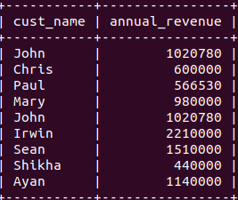

**i) List drivers who have delivered shipments to every city.**

select driver_name from Truck,Shipment where Shipment.truck_no=Truck.truck_no group by driver_name having count(distinct destination)=(select count(city_name) from City);

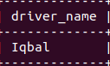

**j) For each city, with a population over 1 million, what is the minimum weight of a package sent to that city.**

select destination,min(weight) from Shipment, City where city_name=destination and population>1000000 group by destination;

